Enterprise Tag Governance Enforcement using AWS Tag Policies
Project 2- AWS Internship
Fortune Cloud Technologies
Prepared by: Aaliya Shaikh
Role: AWS Intern
Tools Used: AWS

1. Introduction
Cloud resources in large organizations are used by multiple teams. Without proper identification of resources, it becomes difficult to track ownership, cost allocation, and compliance requirements. Tagging is a method used in cloud environments to label resources with key–value pairs that help identify important information about them.
In this project, tag governance is implemented using Amazon EC2 and AWS Identity and Access Management to ensure that EC2 instances cannot be launched without mandatory tags. This helps organizations maintain proper governance, improve cost tracking, and meet compliance standards.

2. Problem Statement
In the enterprise cloud environment, EC2 instances were being launched without required tags. This created several problems:
- Resource owners could not be identified.
- Finance teams were unable to allocate costs correctly.
- Compliance audits failed due to missing metadata.
To solve this problem, the cloud governance team required that no EC2 instance should be launched unless mandatory tags are provided.

3. Project Objectives
The main objectives of this project are:
- Enforce mandatory tagging during EC2 instance creation.
- Prevent launching EC2 instances without required tags.
- Implement organization-level governance policies.
- Improve cost management and resource visibility.

4. Required Tags
The following tags are mandatory for every EC2 instance:
Tag Key | Description
Name | Resource owner name
emailID | Official email address
phoneNo | Contact number
Place | Location of the resource

Example:
Key | Value
Name | Aaliya
Email ID | aaliya@gmail.com
Phone No | 9876543210
Place | Pune

5. Technologies Used
Tool | Purpose
Amazon EC2 | Launch and manage virtual machines
AWS Identity and Access Management | Create policies and control permissions
AWS Organizations | Manage policies across accounts (optional)
Service Control Policies | Enforce governance rules across accounts

6. Architecture Overview
Project workflow:
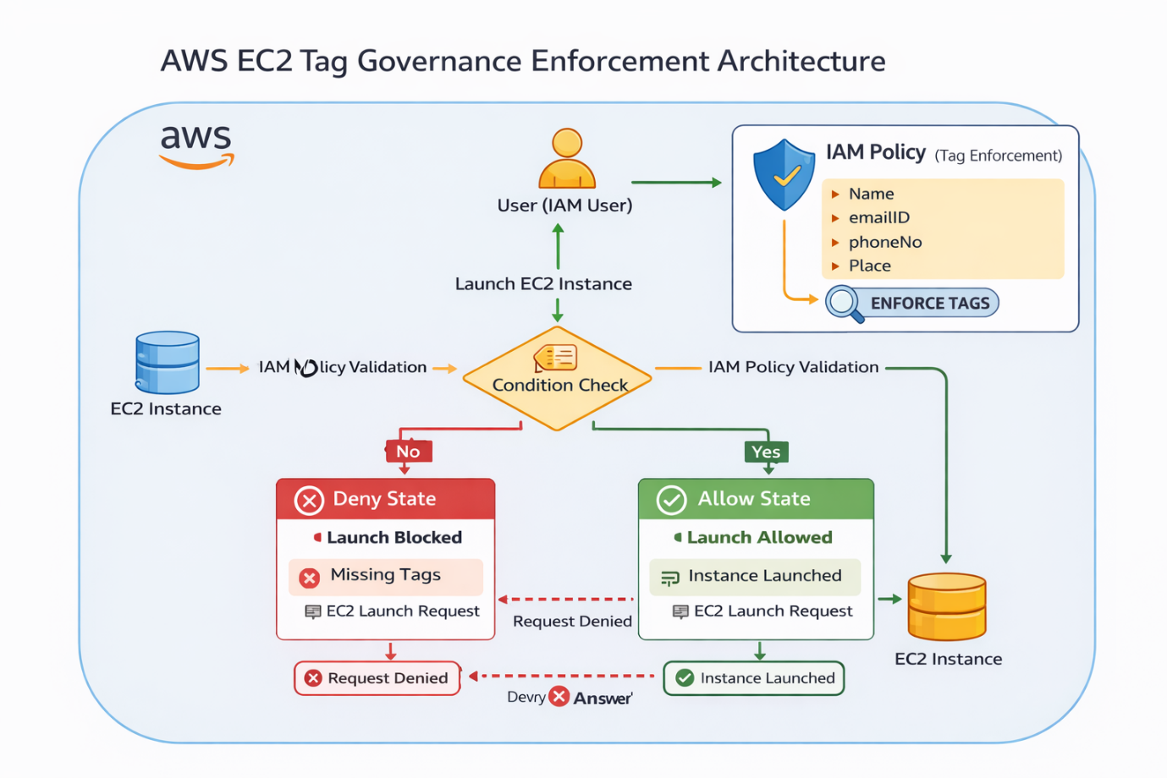

7. IAM Tag Enforcement Policy
The following IAM policy ensures that EC2 instances cannot be launched without mandatory tags:
{
"Version": "2012-10-17",
"Statement": [
{
"Sid": "DenyEC2LaunchWithoutTags",
"Effect": "Deny",
"Action": "ec2:RunInstances",
"Resource": "*",
"Condition": {
"ForAllValues:StringNotEquals": {
"aws:TagKeys": [
"Name",
"emailID",
"phoneNo",
"Place"
]
}
}
}
]
}
This policy denies the EC2 launch operation if required tags are missing.

8. Implementation Steps
Step 1: Create IAM Policy
- Open AWS Console.
- Navigate to IAM.
- Select Policies → Create Policy.
- Choose the JSON editor.
- Paste the tag enforcement policy.
- Save the policy.

Step 2: Attach Policy to User
- Go to IAM Users.
- Select the user account.
- Click Add Permissions.
- Attach the created policy.

Step 3: Launch EC2 Instance Without Tags
- Open EC2 console.
- Click Launch Instance.
- Do not add required tags.
Result:
❌ Instance launch failed due to IAM policy restriction.

Step 4: Launch EC2 Instance With Tags
- Launch EC2 instance again.
- Add the required tags:
Key | Value
Name | Demo
emailID | aaliya@gmail.com
phoneNo | 9876543210
Place | Pune
Result:
✅ Instance launched successfully.

9. Validation
Test Case | Result
Launch EC2 without tags | Failed
Launch EC2 with required tags | Successful
This confirms that the tag enforcement policy is working correctly.

10. Benefits of Tag Governance
Implementing tag governance provides several advantages:
- Improves cost tracking and billing transparency.
- Helps identify resource owners easily.
- Enhances compliance and auditing.
- Enables better resource management.
- Supports automation and reporting.

11. Cost Management Benefits
Tagging helps finance teams generate detailed reports showing which team or department is responsible for cloud usage. This enables better budgeting, chargeback models, and financial accountability.

12.Screenshot
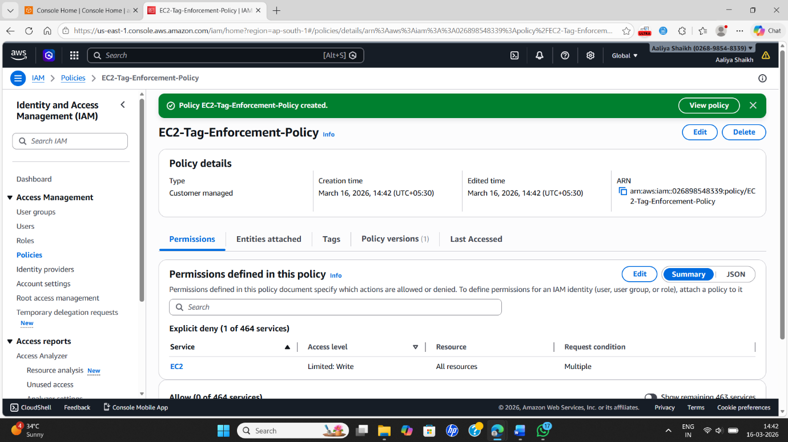

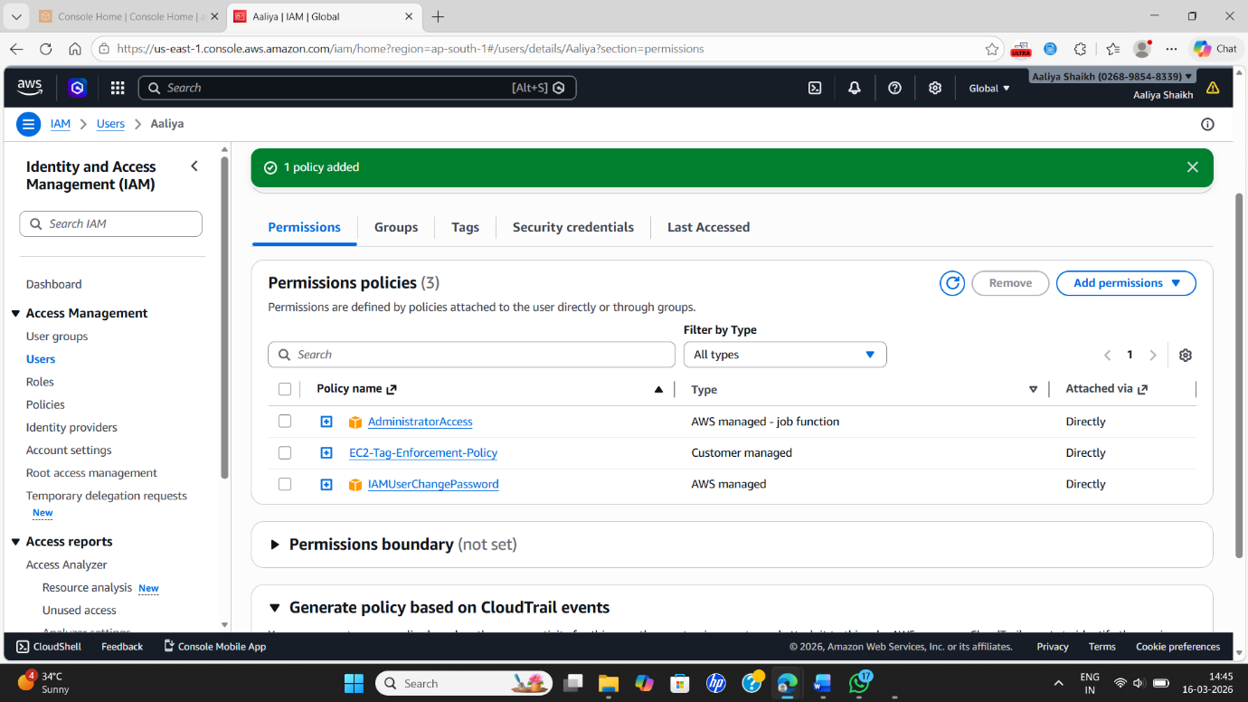

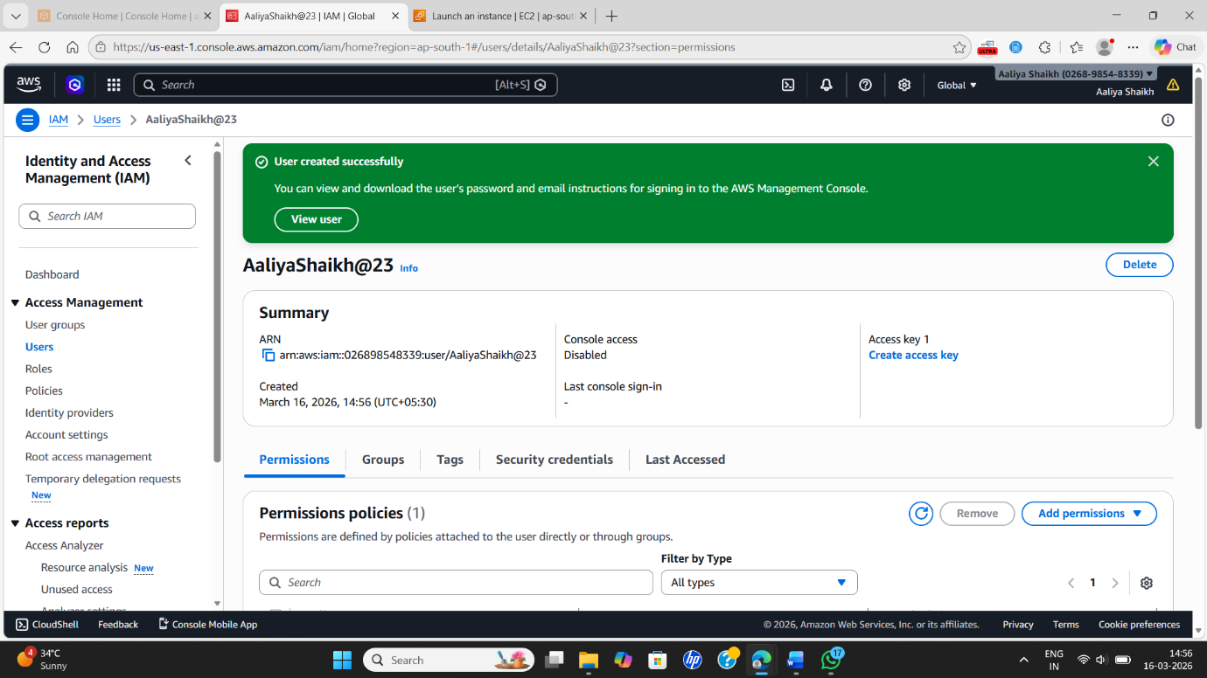

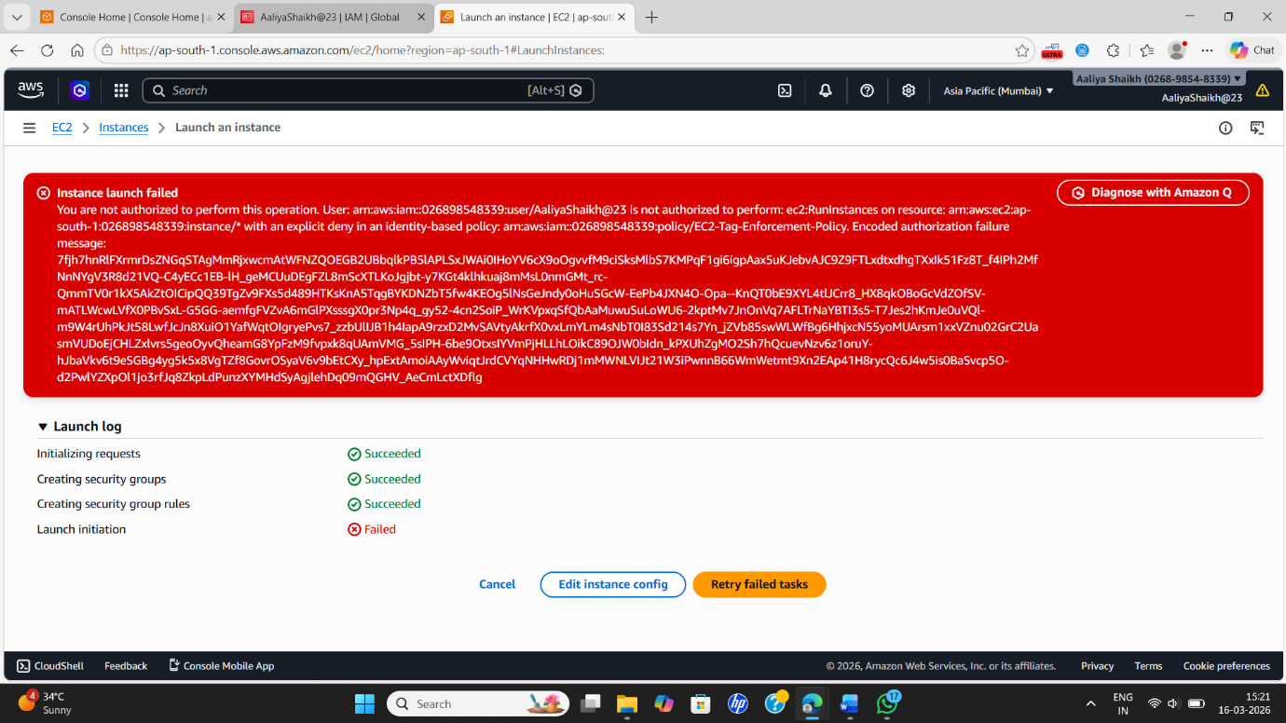

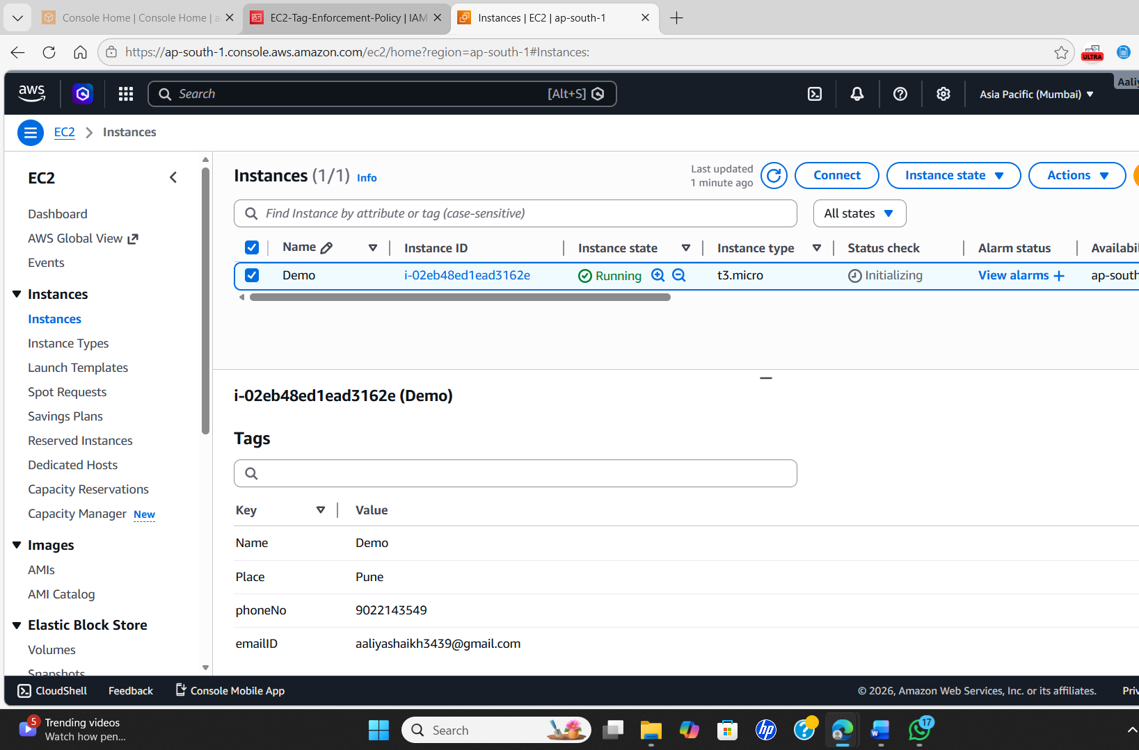

13. Conclusion
This project demonstrates how tagging governance can be enforced in AWS environments. By using IAM policies, organizations can prevent EC2 instances from being created without mandatory tags. This ensures proper resource ownership, accurate cost allocation, and improved compliance. Implementing such governance practices is essential for managing large-scale cloud environments effectively.

